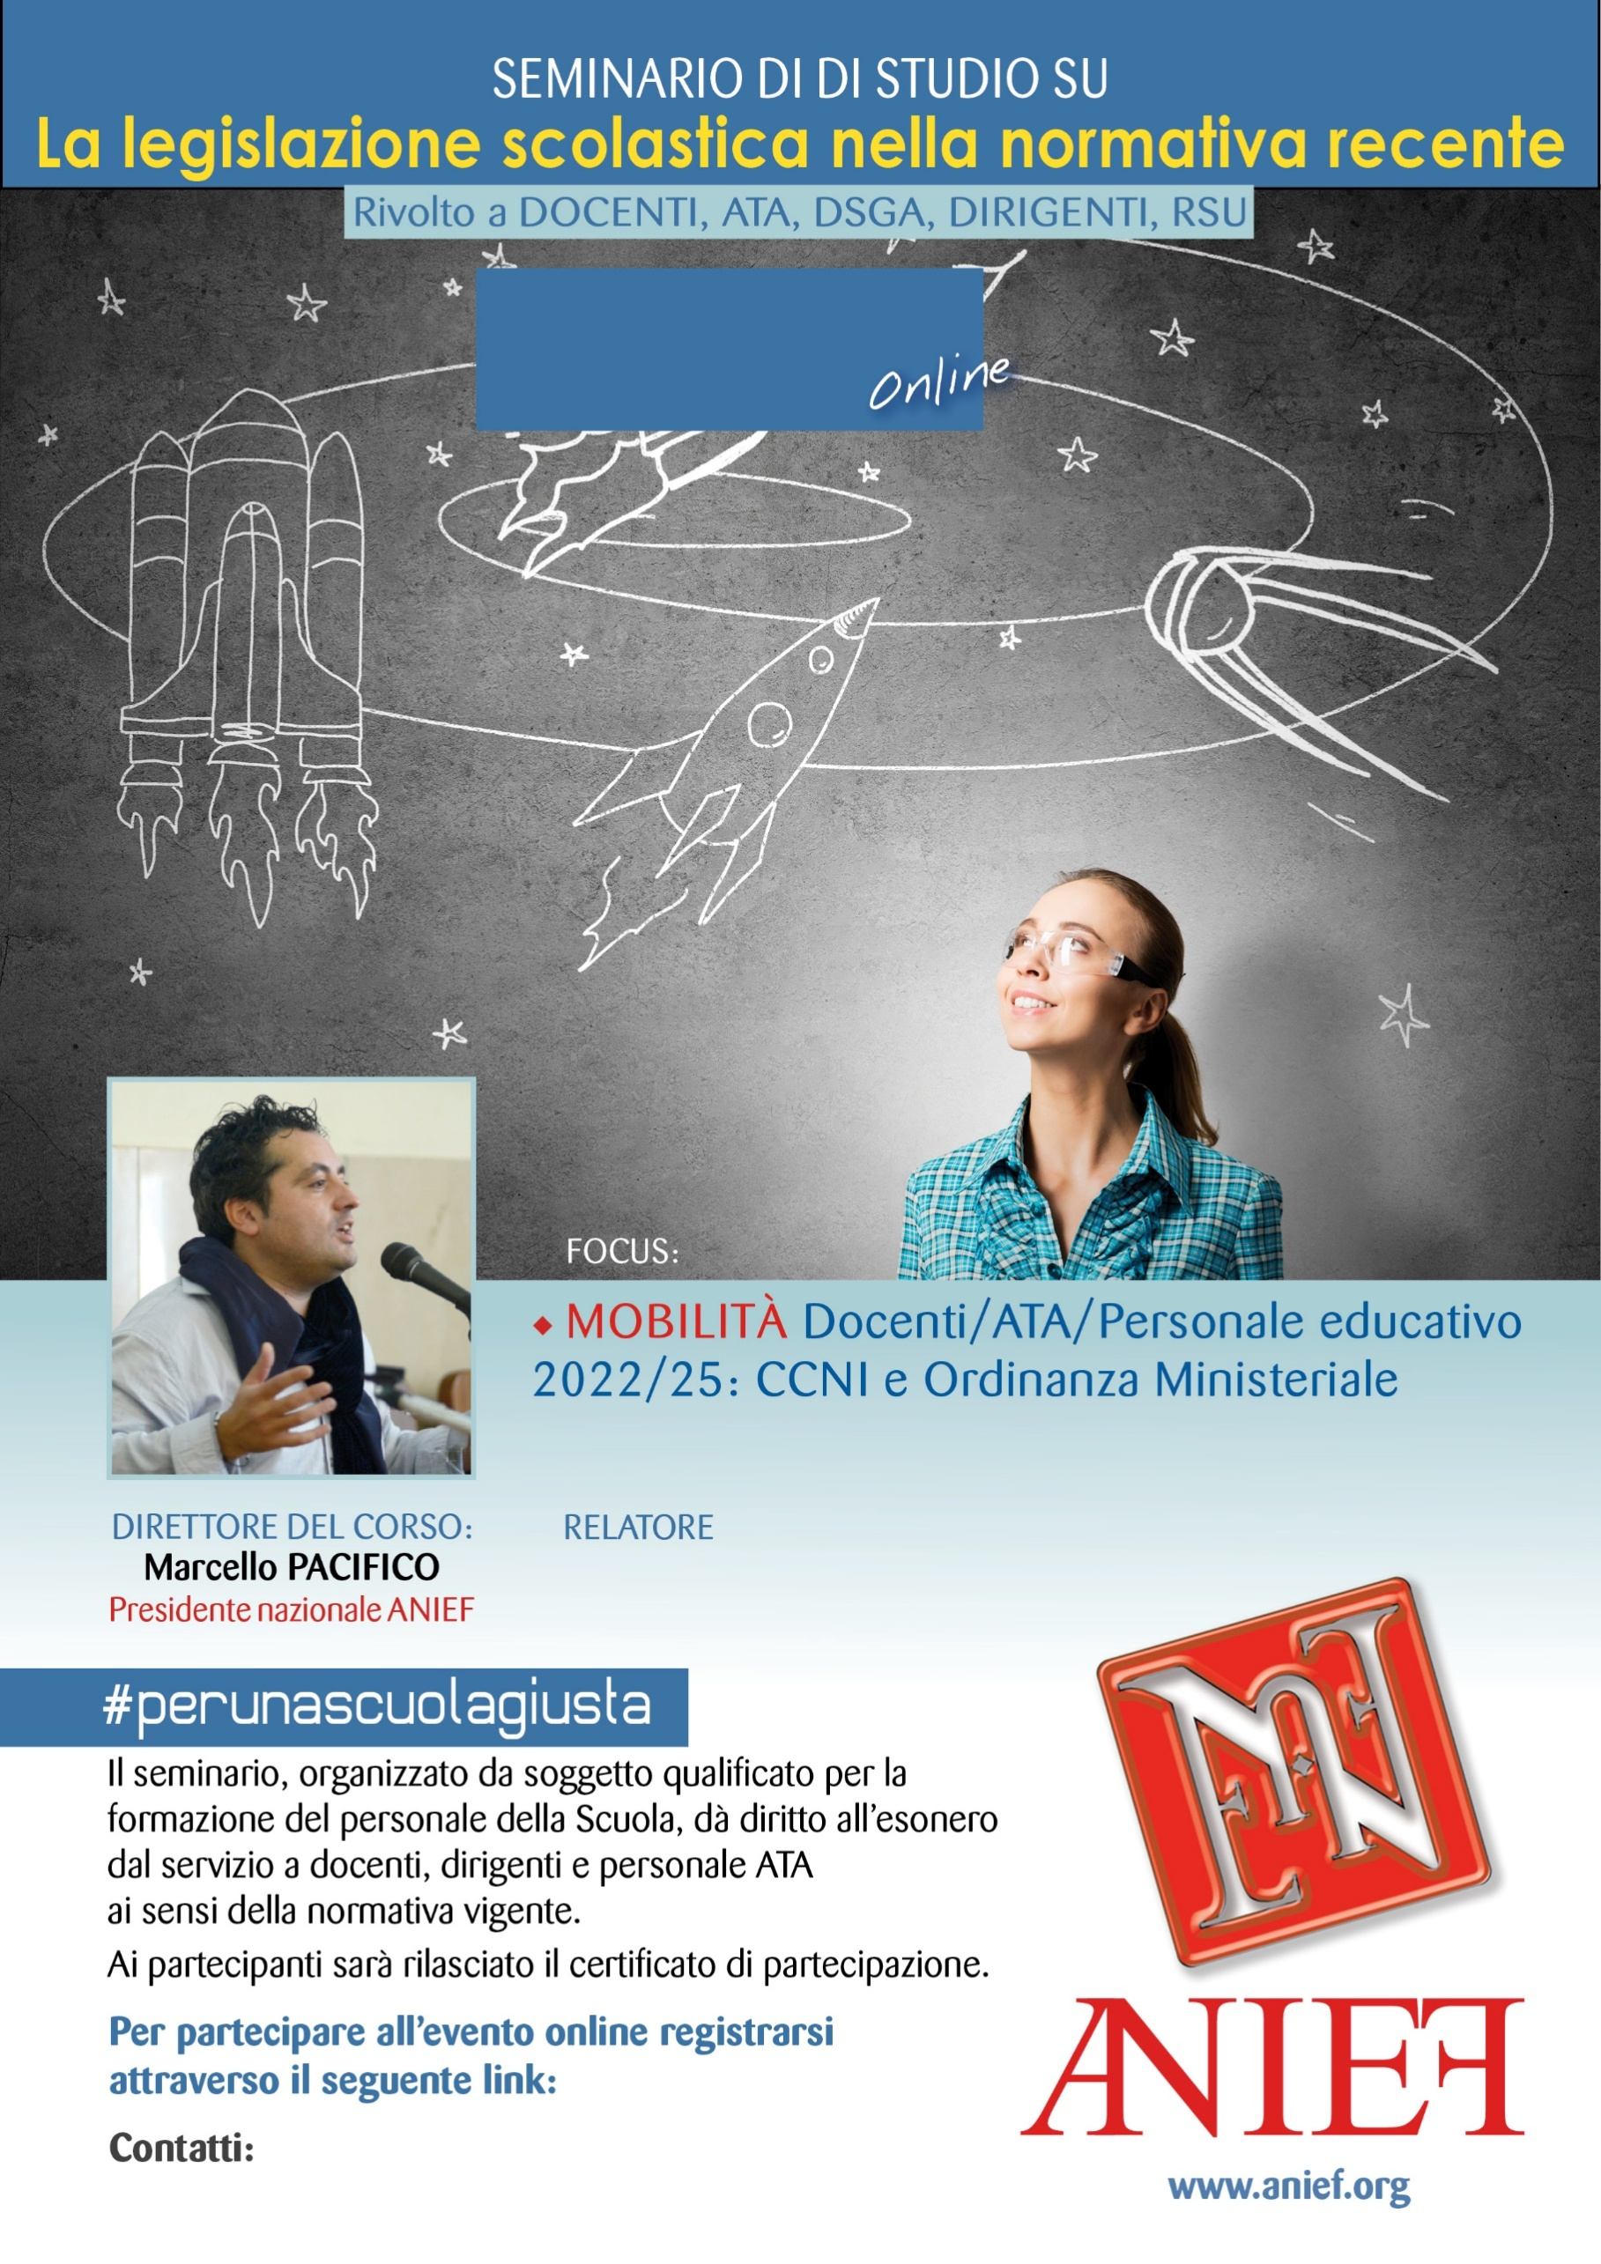

LINK DIRETTA: <https://anief.org/as/3U2H>

napoli1@anief.net

STEFANO CAVALLINI

CAMPANIA - NAPOLI

10/03/2022 ORE 09:00 – 11:00